After School String Ensemble
at North Muskegon Elementary

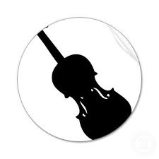
AFTER SCHOOL STRINGS will be available once again this year.
This class will be held on Wednesdays from 3:15-4:00 in the Strings Room. This experience is best suited to enthusiastic and hard working 3rd, 4th, and 5th graders . As we play a variety of styles of music (fiddle songs are our favorite), we will work on becoming proficient “note readers” and ensemble musicians. Our repertoire will be diverse but challenging. We’ll stretch our notation reading skills, learn beginning string quartet music, fiddle-tunes or special requests and then look for performance opportunities in our community!

This after-school ensemble is offered as a private class by Mrs. Corbin for highly motivated students in grades 3-5. The cost to participate is $5 per class, to be paid in advanced per 8-week session. Interested students should talk to Mrs. Corbin about their readiness for this group.
Schedule
Session I: (8 weeks)  September November  Cost: $40.00 | Session II:  January-February  Cost: $40.00 | Session III:  April 2-May 28  Cost: $40.00

Please detach registration form (below) and return to Mrs. Corbin with payment.
Cash or checks payable to Angela Corbin.

Student Name: _____________________________Grade:____ Teacher:__________
Instrument: ________________ Years Played: _____ Private Lessons? Y / N
Parent/Guardian Name(s):_______________________________________________
Contact Phone Number(s):_______________________________________________
Email: _________________________________________________________________

The total cost for After School Strings Session III is $40.00
Payment Attached? Y / N Amount: ____________

