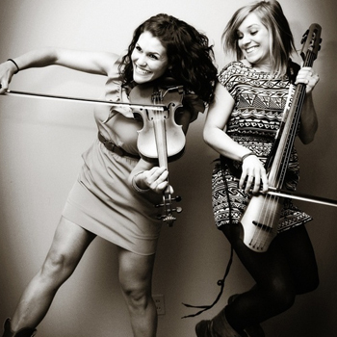
January 16, 2014
A Day with …

The Moxie Strings

A Fiddle Clinic & Evening Concert with
The Moxie Strings at North Muskegon Schools

One whole school day of back-to-back interactive workshops for North Muskegon Strings Students (Grades 2-12). Fourth - Twelfth Grade Strings students will learn fiddling skills, improvisational skills, string playing technique, and a fiddle tune to perform with the Moxie Strings. Plus: Interactive presentations for 2nd and 3rd Grade string players AND an evening concert.

What we need: $1900
Please consider supporting our Strings Students to make this exciting concert and learning experience a reality!
---------------------------------------------------------------------------------------------------------------------------------------
North Muskegon Strings Clinic and Moxie Strings Concert Giving Information
Individuals or Business that would like to help, please mail this form with your contribution to:
North Muskegon Elementary Orchestra
Attn: Angela Corbin
1600 Mills Avenue
North Muskegon, MI 49445
(Individual or Business) Name___________________________________ Phone __________________ Address________________________________________E-mail_______________________________
Donation Amount:__________ Would you like to be mentioned/featured in the concert program? Y N
NORSEMEN Up to $100
BLUE $101-$250
GOLD $251-$500
DIRECTOR’S CIRCLE $500 or more
Concert underwriting opportunities also available (please contact Angela Corbin) Questions? corbinan@nmps.k12.mi.us

